Tetrakis Hexahedron

Definition
# Source: AI Source: Provided by: [Data Path: Persons Table -> ID Column: 1, Name_En Column: Motasem Essam] -> From: [ChatGPT] on [7/25/2026]
A Tetrakis Hexahedron is a convex Catalan solid formed by attaching a square pyramid to each of the six faces of a cube.
It has 24 congruent isosceles triangular faces, 36 edges, and 14 vertices. It is the dual of the truncated octahedron, one of the Archimedean solids.
It is also called a Tetrakis Cube because its construction is based on a cube.

Simple Definition
# Source: AI Source: Provided by: [Data Path: Persons Table -> ID Column: 1, Name_En Column: Motasem Essam] -> From: [ChatGPT] on [7/25/2026]
A Tetrakis Hexahedron looks like a cube with a square pyramid attached to each of its six faces. Each square face is divided into four triangular faces by connecting its four corners to the pyramid's apex.
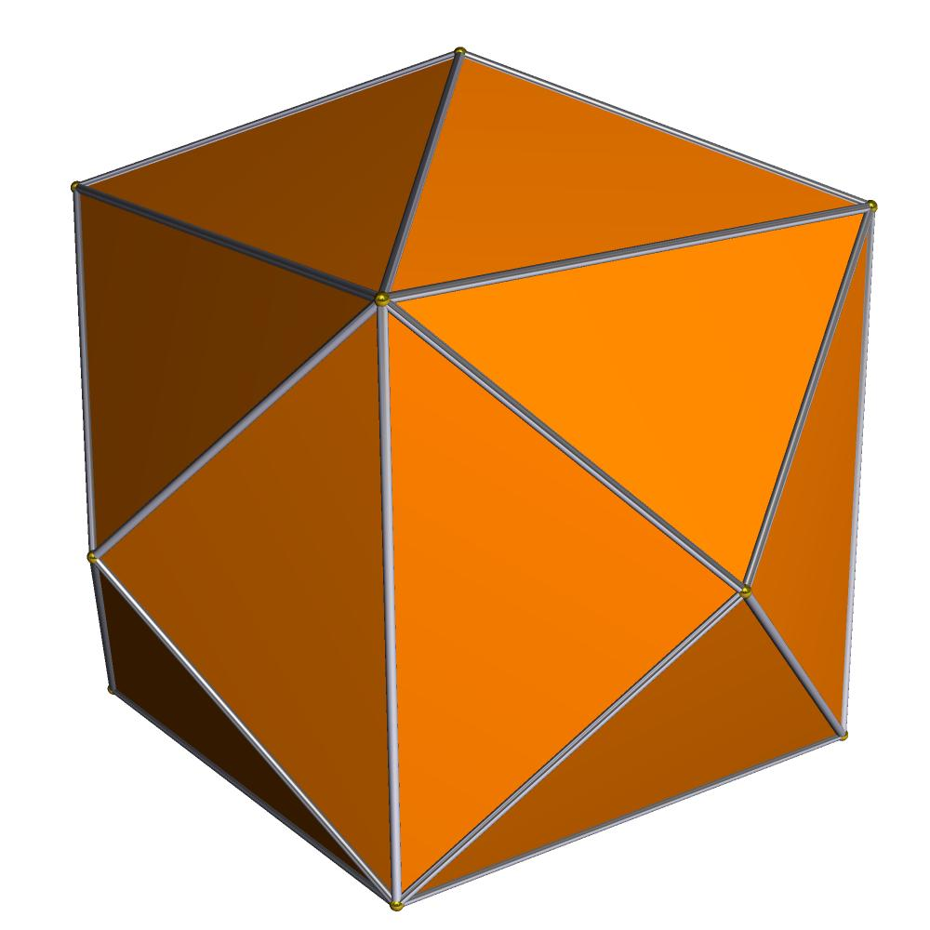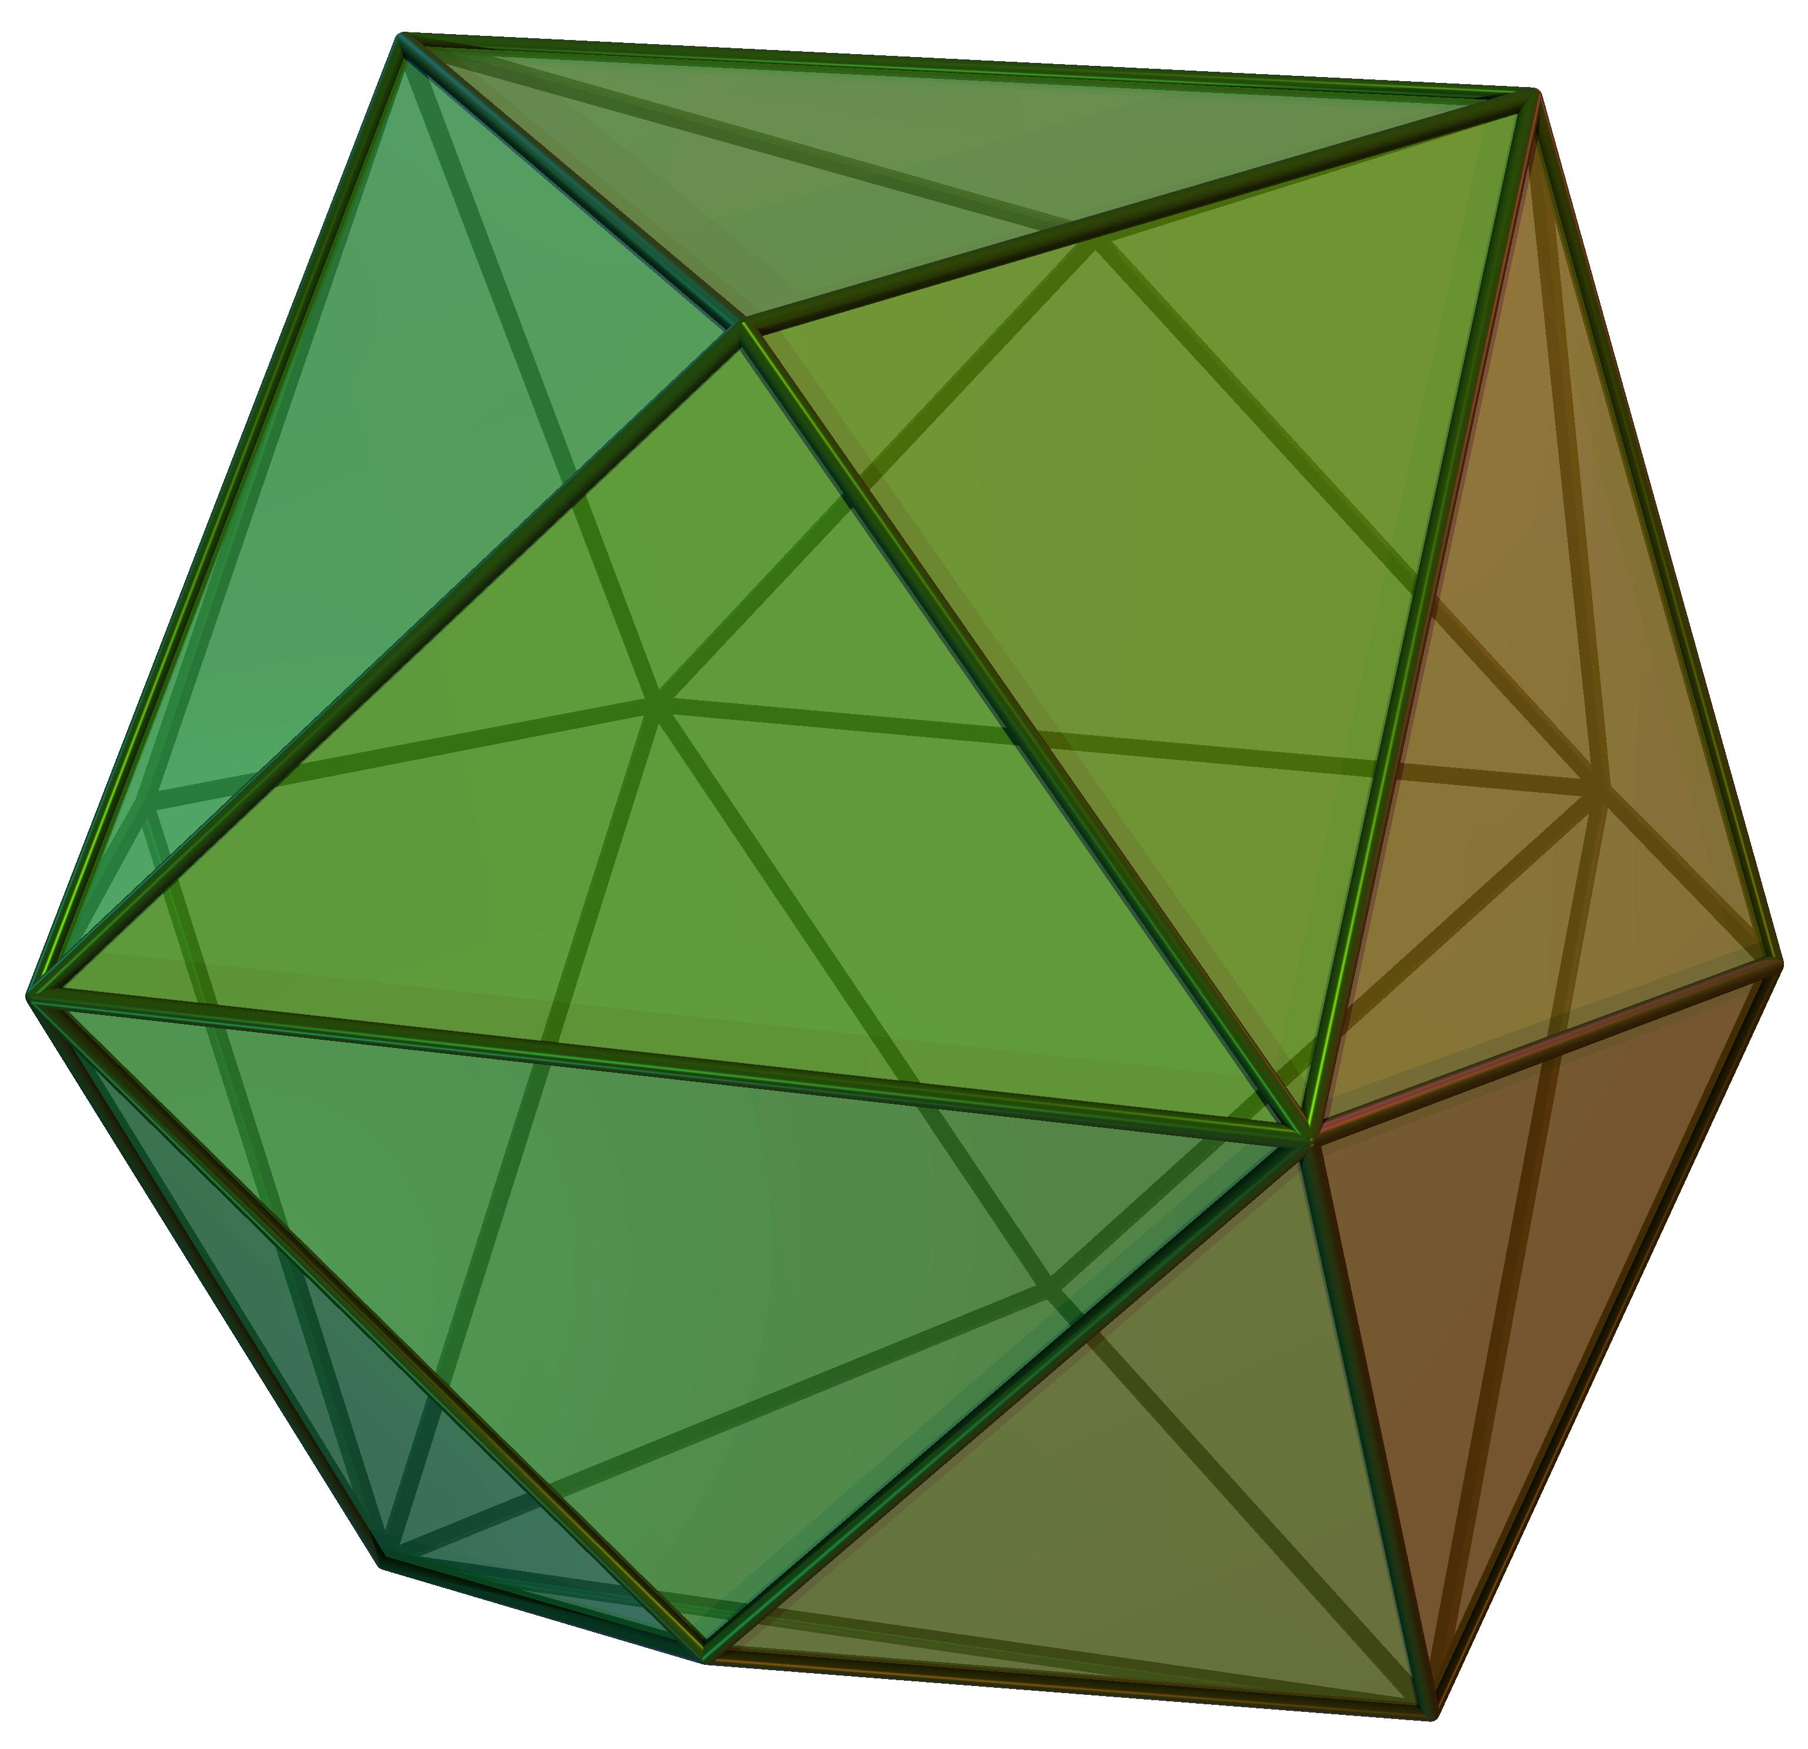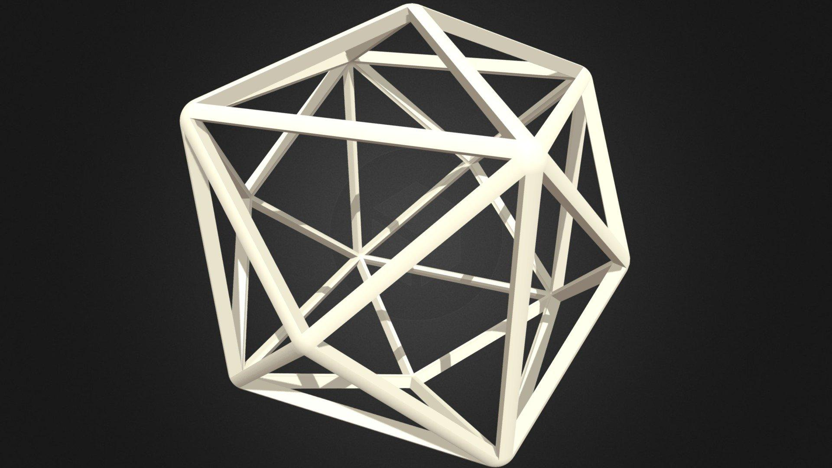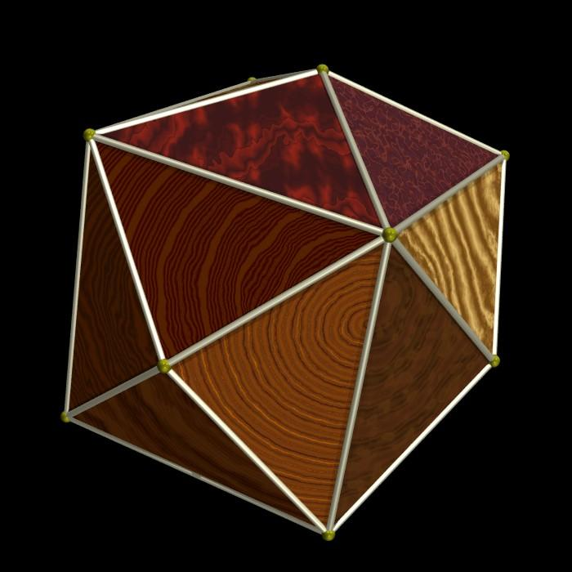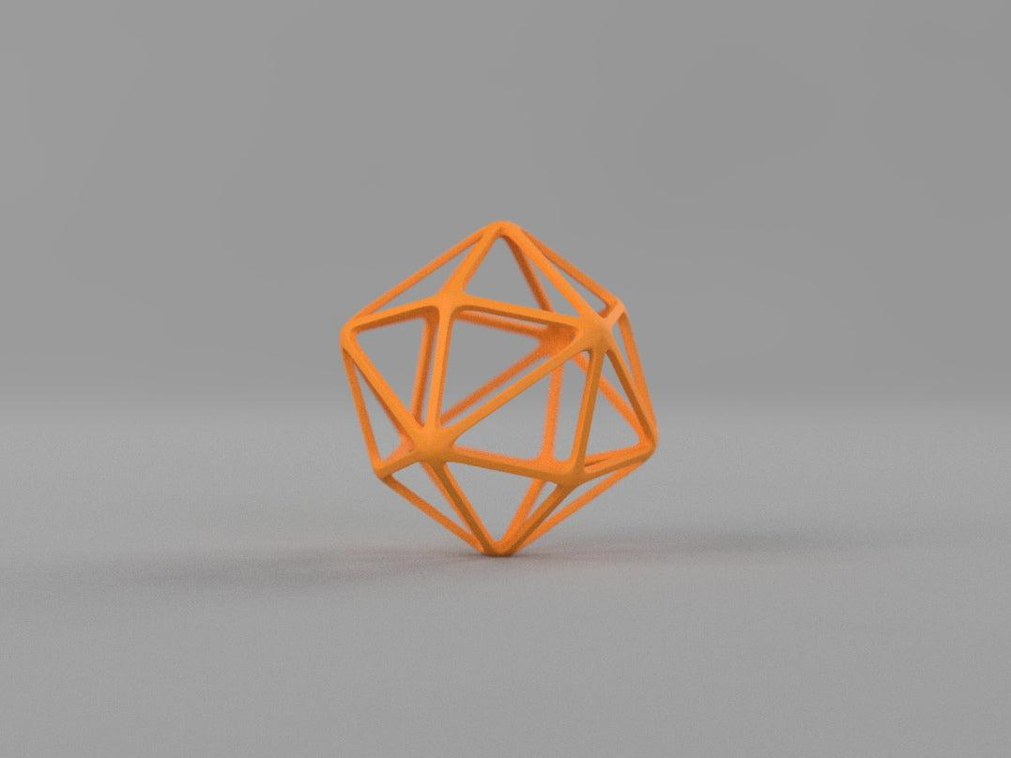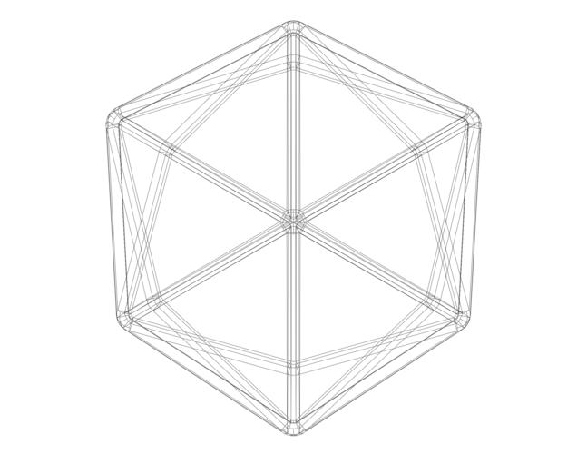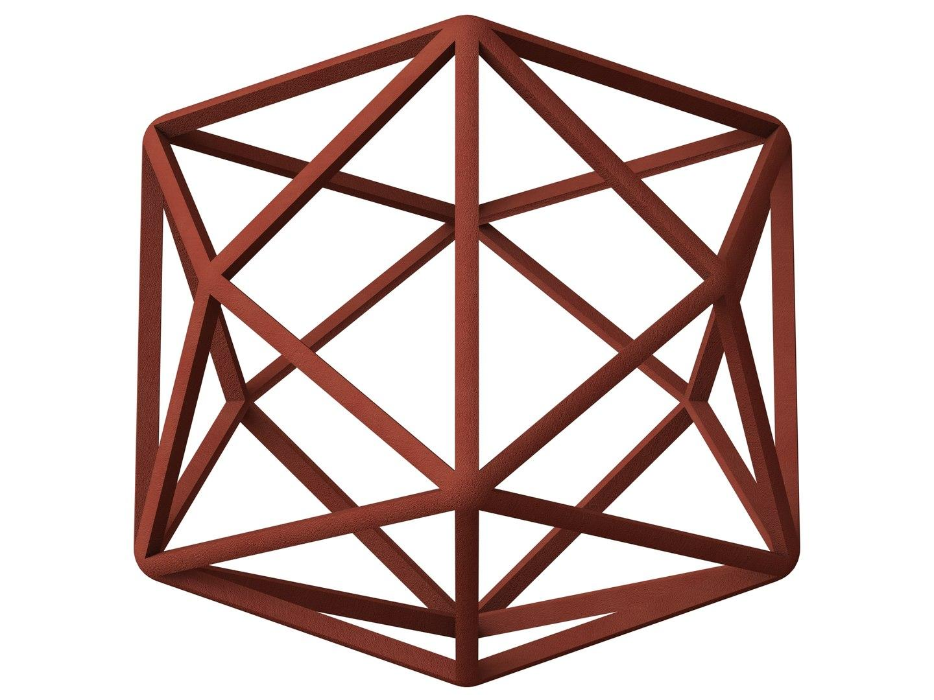

Geometric Structure
# Source: AI Source: Provided by: [Data Path: Persons Table -> ID Column: 1, Name_En Column: Motasem Essam] -> From: [ChatGPT] on [7/25/2026]
- It is based on a cube.
- Six square pyramids are attached, one to each cube face.
- Each square pyramid contributes four triangular faces.
- The resulting solid has 24 congruent isosceles triangular faces.
- It is convex and has octahedral symmetry.
The standard Catalan form is obtained when the height of each attached pyramid is one-quarter of the cube's side length.

Face Structure
# Source: AI Source: Provided by: [Data Path: Persons Table -> ID Column: 1, Name_En Column: Motasem Essam] -> From: [ChatGPT] on [7/25/2026]
The Tetrakis Hexahedron has:
- 24 faces in total.
- All faces are congruent isosceles triangles.
- Each triangular face has two equal shorter edges and one longer edge.
- The two shorter edges and the longer edge have the ratio $3:4$.
For the standard form, the triangle's angles are approximately:
- Two equal angles: ${48.19}^{°}$ each.
- One larger angle: ${83.62}^{°}$.

Edge Structure
# Source: AI Source: Provided by: [Data Path: Persons Table -> ID Column: 1, Name_En Column: Motasem Essam] -> From: [ChatGPT] on [7/25/2026]
The solid has 36 edges, divided into two groups:
- 24 shorter edges.
- 12 longer edges.
The shorter edges connect the pyramid apices to the original cube vertices. The longer edges correspond to the edges of the original cube.
Let $s$ be the shorter edge and $L$ the longer edge:
$$s:L=3:4$$
Therefore:
$$L=\frac{4}{3}s$$

Vertex Structure
# Source: AI Source: Provided by: [Data Path: Persons Table -> ID Column: 1, Name_En Column: Motasem Essam] -> From: [ChatGPT] on [7/25/2026]
The Tetrakis Hexahedron has 14 vertices, divided into two groups:
- 6 vertices of degree 4: Four triangular faces meet at each of these vertices. They correspond to the six pyramid apices.
- 8 vertices of degree 6: Six triangular faces meet at each of these vertices. They correspond to the eight original cube vertices.
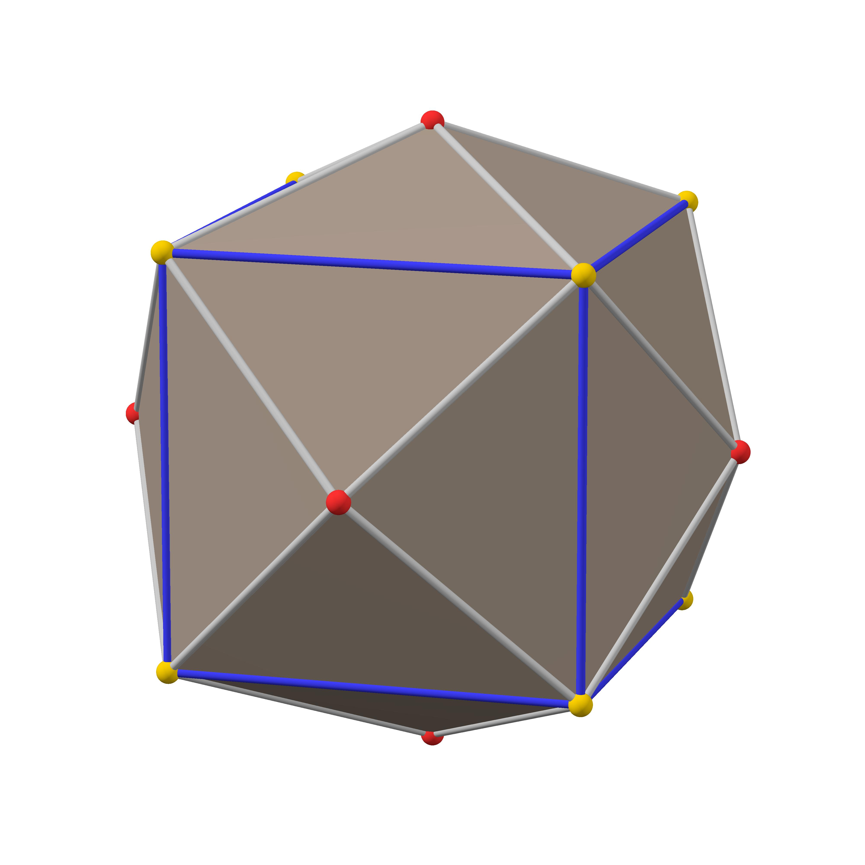

Mathematical Properties
# Source: AI Source: Provided by: [Data Path: Persons Table -> ID Column: 1, Name_En Column: Motasem Essam] -> From: [ChatGPT] on [7/25/2026]
24
Faces
36
Edges
14
Vertices
143.13°
Dihedral angle
Euler's formula
$$V-E+F=2$$
$$14-36+24=2$$
The Tetrakis Hexahedron satisfies Euler's polyhedron formula.

Face angles
# Source: AI Source: Provided by: [Data Path: Persons Table -> ID Column: 1, Name_En Column: Motasem Essam] -> From: [ChatGPT] on [7/25/2026]
Each isosceles triangular face has:
$${48.19}^{°}+{48.19}^{°}+{83.62}^{°}={180}^{°}$$

Edge-length ratio
# Source: AI Source: Provided by: [Data Path: Persons Table -> ID Column: 1, Name_En Column: Motasem Essam] -> From: [ChatGPT] on [7/25/2026]
$$\frac{s}{L}=\frac{3}{4}$$
where $s$ is the shorter edge and $L$ is the longer edge.

Symmetry
# Source: AI Source: Provided by: [Data Path: Persons Table -> ID Column: 1, Name_En Column: Motasem Essam] -> From: [ChatGPT] on [7/25/2026]
The Tetrakis Hexahedron has full octahedral symmetry, represented by the symmetry group:
$$O_{h}$$
Its symmetry includes:
- Four-fold rotational axes.
- Three-fold rotational axes.
- Two-fold rotational axes.
- Reflection planes.
- Central inversion symmetry.
It is face-transitive and vertex-transitive within each of its two vertex groups, but not across both groups.

Surface Area and Volume
# Source: AI Source: Provided by: [Data Path: Persons Table -> ID Column: 1, Name_En Column: Motasem Essam] -> From: [ChatGPT] on [7/25/2026]
Let $s$ represent the length of a shorter edge.
For the standard Tetrakis Hexahedron:
Surface area
$$SA=\frac{16\sqrt{5}}{3}s^{2}$$
Volume
$$V=\frac{32}{9}s^{3}$$
These formulas use the shorter-edge normalization $s=1$ as their reference scale.

Relationship to Other Solids

Dual: Truncated Octahedron
# Source: AI Source: Provided by: [Data Path: Persons Table -> ID Column: 1, Name_En Column: Motasem Essam] -> From: [ChatGPT] on [7/25/2026]
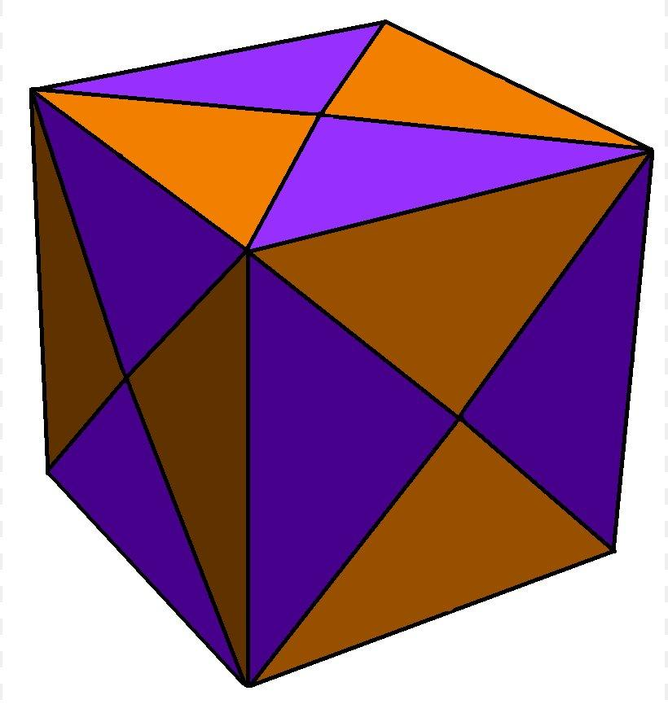
Tetrakis Hexahedron
Catalan solid
<icon name="arrow-left-right" size="xl"/>
Duality
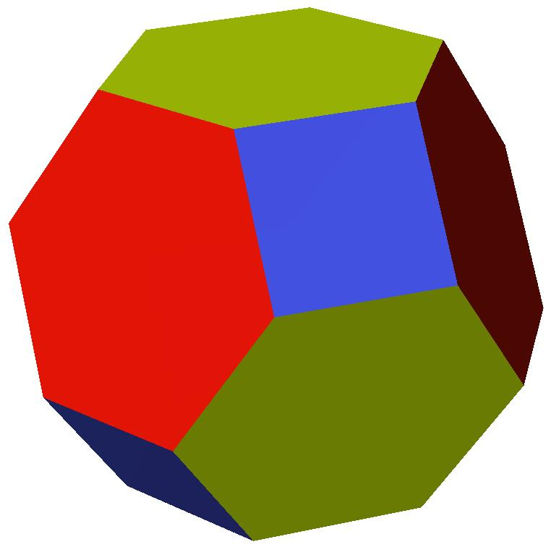
Truncated Octahedron
Archimedean solid
The Tetrakis Hexahedron is the dual of the Truncated Octahedron.
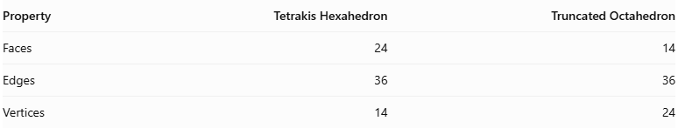
Property | Tetrakis Hexahedron | Truncated Octahedron
Faces | 24 | 14
Edges | 36 | 36
Vertices | 14 | 24
In polyhedral duality:
- Each face of the Tetrakis Hexahedron corresponds to a vertex of the Truncated Octahedron.
- Each vertex of the Tetrakis Hexahedron corresponds to a face of the Truncated Octahedron.
- Their edges correspond to each other.

Construction of Tetrakis Hexahedron

Geometric Instruments Used
# Source: AI Source: Provided by: [Data Path: Persons Table -> ID Column: 1, Name_En Column: Motasem Essam] -> From: [ChatGPT] on [7/25/2026]
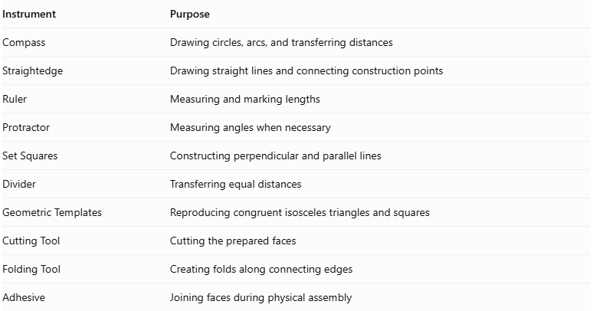
Instrument | Purpose
Compass | Drawing circles, arcs, and transferring distances
Straightedge | Drawing straight lines and connecting construction points
Ruler | Measuring and marking lengths
Protractor | Measuring angles when necessary
Set Squares | Constructing perpendicular and parallel lines
Divider | Transferring equal distances
Geometric Templates | Reproducing congruent isosceles triangles and squares
Cutting Tool | Cutting the prepared faces
Folding Tool | Creating folds along connecting edges
Adhesive | Joining faces during physical assembly

Instrument-Based Construction Procedures

Step 1: Construct the Central Cube
# Source: AI Source: Provided by: [Data Path: Persons Table -> ID Column: 1, Name_En Column: Motasem Essam] -> From: [ChatGPT] on [7/25/2026]
- Select a cube edge length $a$.
- Draw a square using a ruler and straightedge.
- Construct perpendicular edges of equal length at the appropriate vertices.
- Complete the remaining square faces using parallel and perpendicular construction.
- Verify that all six faces are congruent squares.
- Check that all 12 edges have equal lengths.
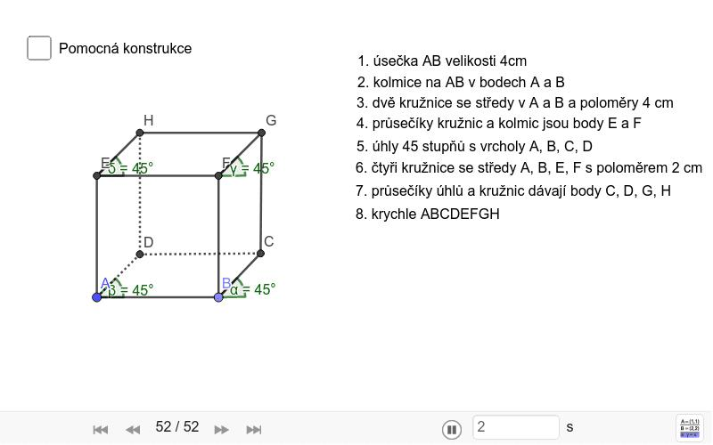

Step 2: Locate the Centers of the Six Cube Faces
# Source: AI Source: Provided by: [Data Path: Persons Table -> ID Column: 1, Name_En Column: Motasem Essam] -> From: [ChatGPT] on [7/25/2026]
- Select one square face of the cube.
- Draw its two diagonals using a straightedge.
- Mark their intersection as the face center.
- Repeat for the remaining five faces.
- Verify that each center is equidistant from the four vertices of its square face.
These six centers determine the positions of the six attached pyramid apexes.
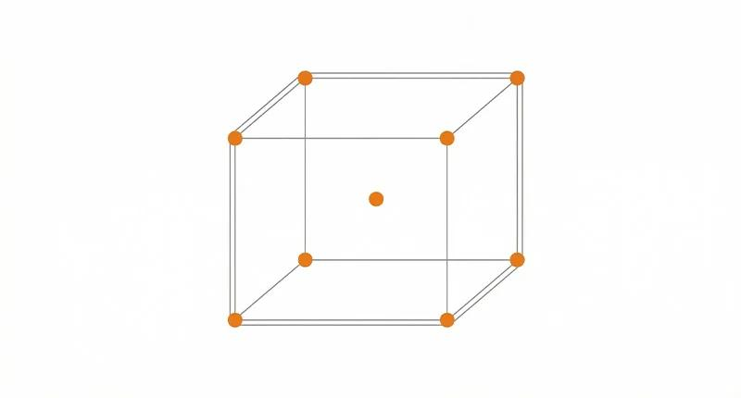

Step 3: Construct Perpendicular Lines Through the Face Centers
# Source: AI Source: Provided by: [Data Path: Persons Table -> ID Column: 1, Name_En Column: Motasem Essam] -> From: [ChatGPT] on [7/25/2026]
- Select one square face of the cube.
- Locate its center.
- Construct a line perpendicular to the face through its center.
- Extend the line outward from the cube.
- Repeat for the remaining five faces.
The six perpendicular lines define the directions of the attached pyramid apexes.

Step 4: Determine the Heights of the Square Pyramids
# Source: AI Source: Provided by: [Data Path: Persons Table -> ID Column: 1, Name_En Column: Motasem Essam] -> From: [ChatGPT] on [7/25/2026]
For a central cube with edge length $a$, each attached square pyramid must have a perpendicular height of:
$$\boxed{h=\frac{a}{4}}$$
- Set the ruler to one-quarter of the cube's edge length.
- Measure this distance along each outward perpendicular line.
- Mark the apex position on each line.
- Repeat for all six cube faces.
This height produces the standard Tetrakis Hexahedron with 24 congruent triangular faces.

Step 5: Construct the Six Square Pyramids
# Source: AI Source: Provided by: [Data Path: Persons Table -> ID Column: 1, Name_En Column: Motasem Essam] -> From: [ChatGPT] on [7/25/2026]
- Select one square face of the central cube.
- Identify its four vertices and its center.
- Mark the pyramid apex at the previously determined height.
- Connect the apex to the four vertices of the square base.
- Form four isosceles triangular lateral faces.
- Repeat for all six cube faces.
Each square pyramid contributes four exterior triangular faces.
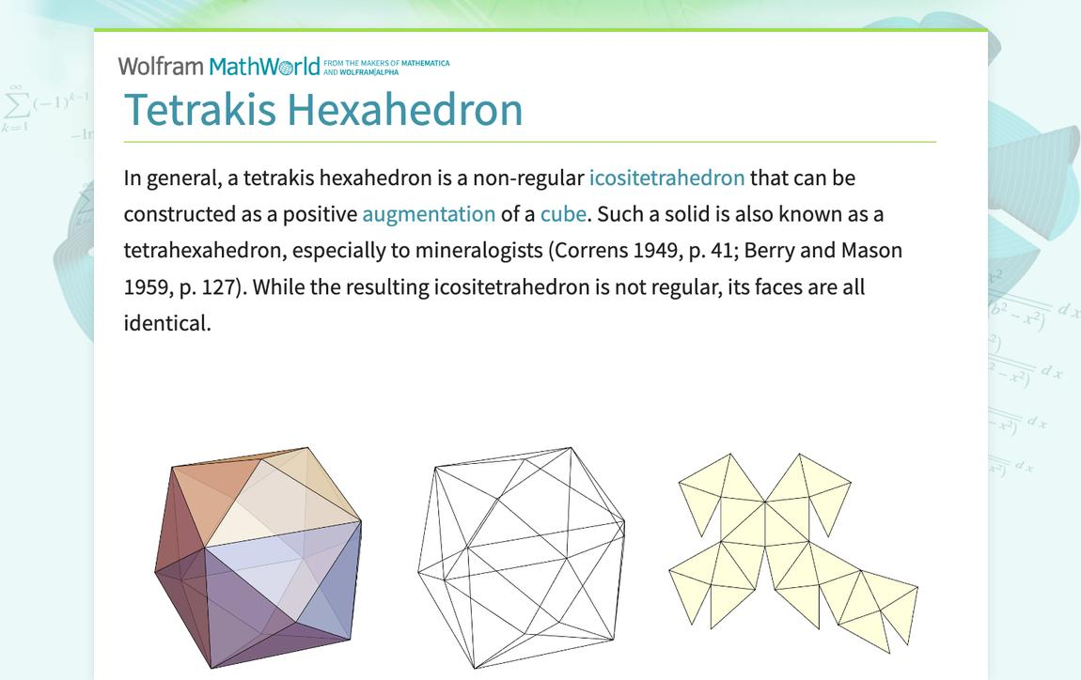

Step 6: Form the Twenty-Four Triangular Faces
# Source: AI Source: Provided by: [Data Path: Persons Table -> ID Column: 1, Name_En Column: Motasem Essam] -> From: [ChatGPT] on [7/25/2026]
- Examine the four lateral triangular faces of each square pyramid.
- Identify the original cube edges that form the longer sides of the triangles.
- Preserve the triangular faces as separate exterior faces.
- Verify that every triangle has two equal short edges and one long edge.
- Repeat for all six pyramids.
- Confirm that the complete structure contains 24 congruent triangles.

Step 7: Verify the Three-Dimensional Structure
# Source: AI Source: Provided by: [Data Path: Persons Table -> ID Column: 1, Name_En Column: Motasem Essam] -> From: [ChatGPT] on [7/25/2026]
- Check that all 24 faces are congruent isosceles triangles.
- Verify that 24 edges are short and 12 are long.
- Confirm that six vertices have valency 4.
- Confirm that eight vertices have valency 6.
- Check that the completed solid is convex.
- Verify that the six pyramid apexes are arranged symmetrically around the central cube.
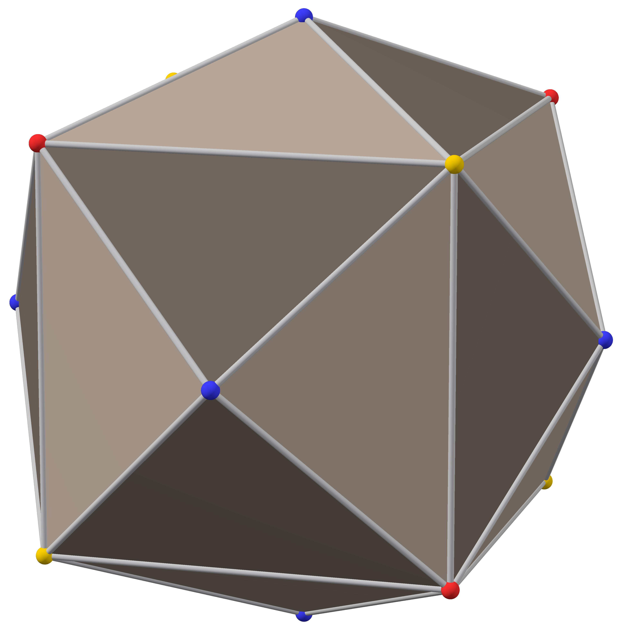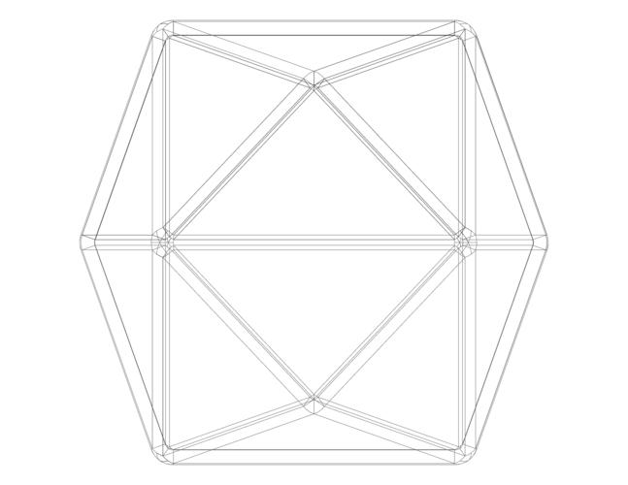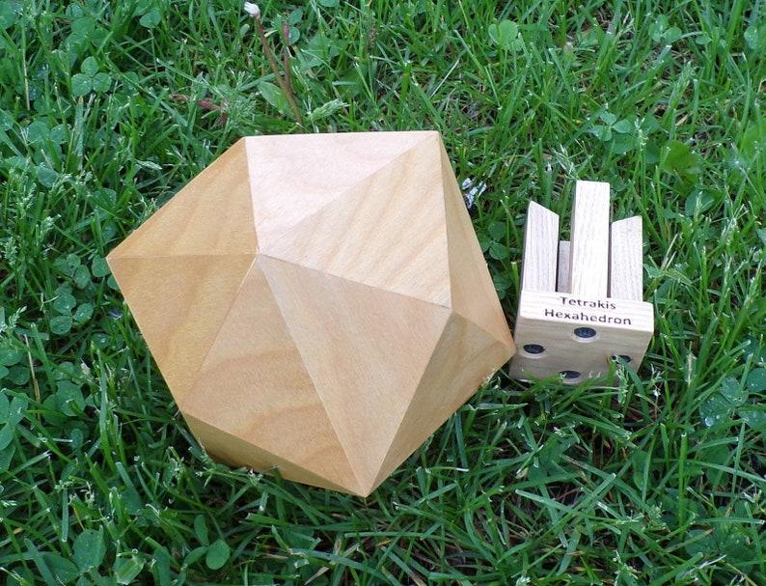

Step 8: Prepare the Faces for Physical Assembly
# Source: AI Source: Provided by: [Data Path: Persons Table -> ID Column: 1, Name_En Column: Motasem Essam] -> From: [ChatGPT] on [7/25/2026]
- Construct one accurate isosceles triangular face.
- Set its two shorter sides to $3a/4$ and its longer side to $a$.
- Reproduce the triangular face 24 times.
- Mark the corresponding edge connections.
- Arrange the faces according to a verified Tetrakis Hexahedron net.
- Cut out the faces and prepare joining tabs if necessary.
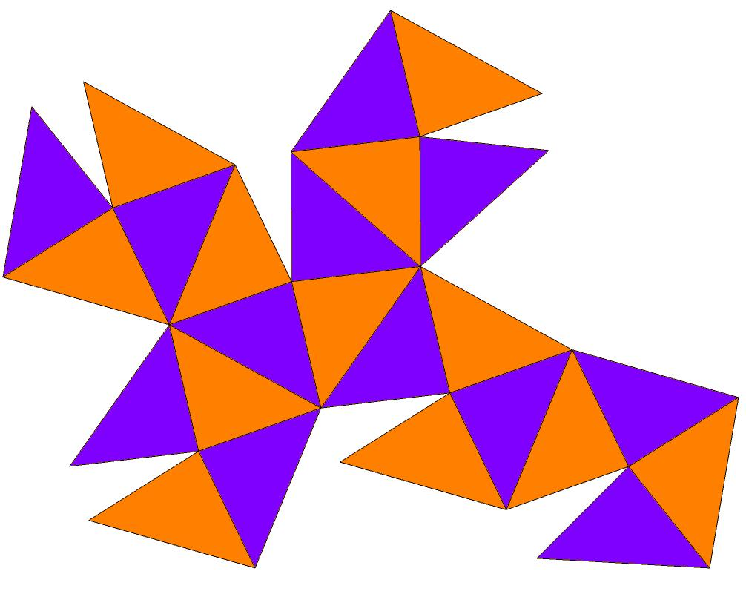

Step 9: Assemble the Three-Dimensional Solid
# Source: AI Source: Provided by: [Data Path: Persons Table -> ID Column: 1, Name_En Column: Motasem Essam] -> From: [ChatGPT] on [7/25/2026]
- Fold or position the 24 triangular faces along their designated edges.
- Connect adjacent faces according to the verified net.
- Maintain the correct four-valent and six-valent vertex arrangements.
- Close the remaining openings.
- Inspect the completed solid for equal face shapes and the required edge-length ratio.
- Verify its overall octahedral symmetry.
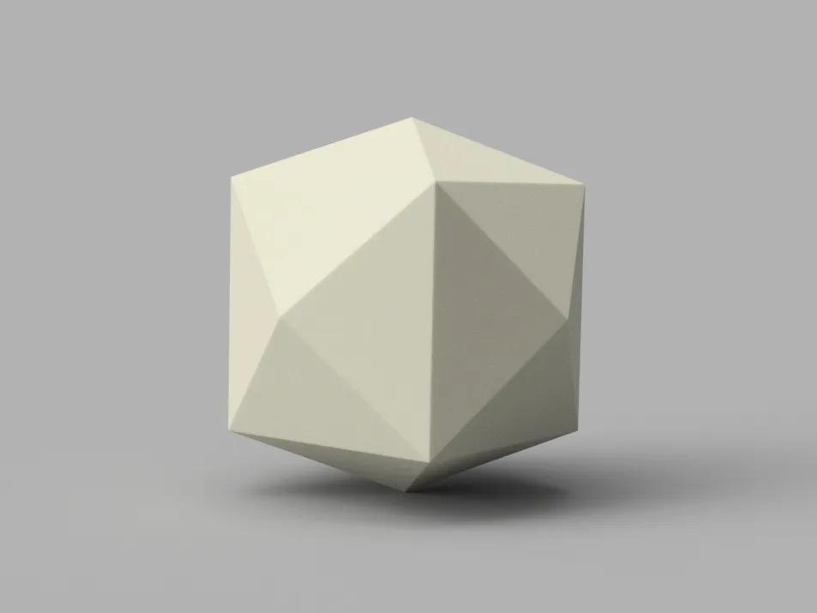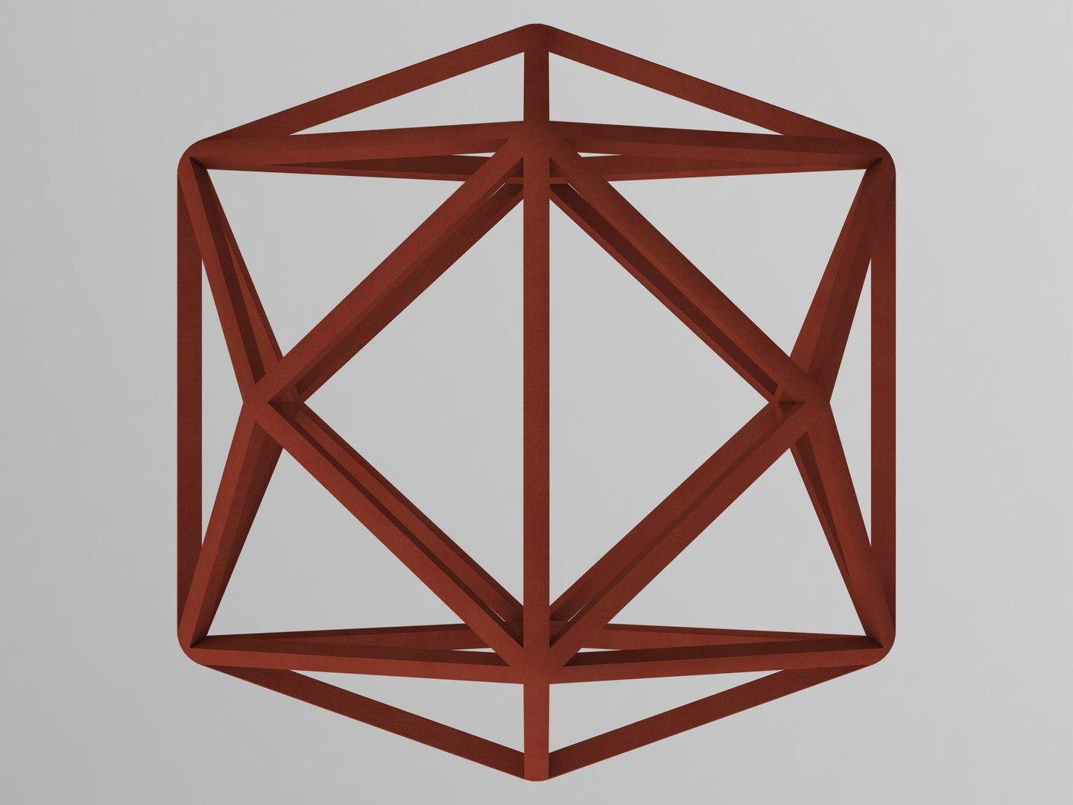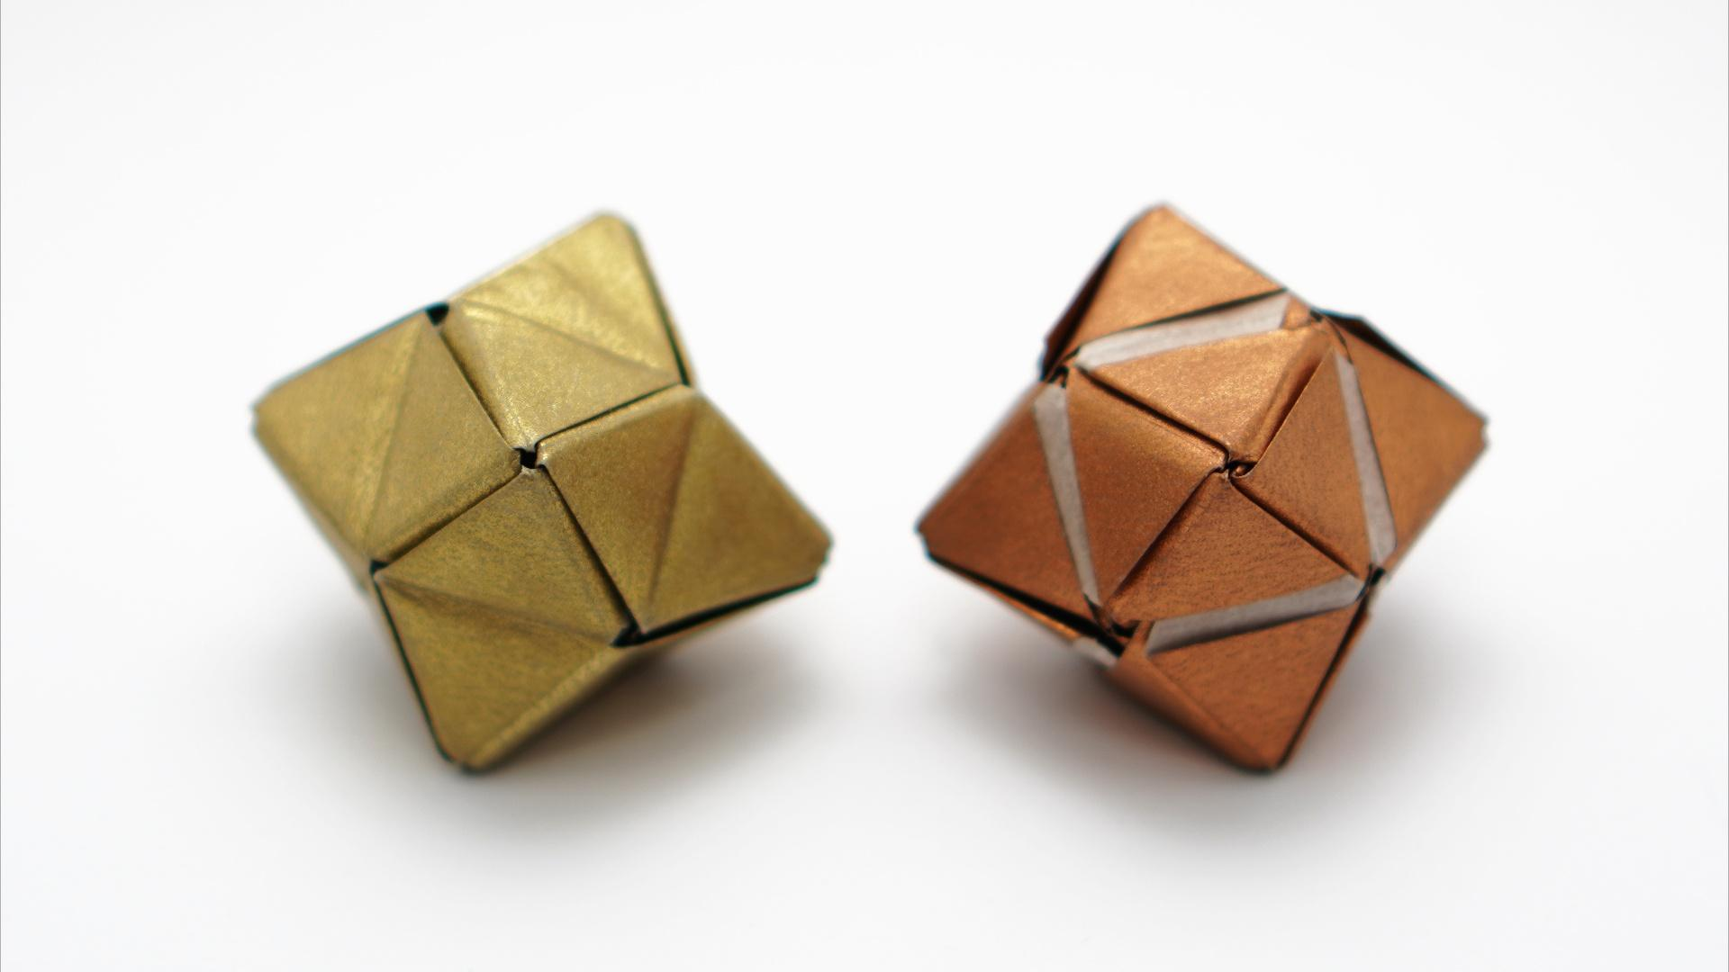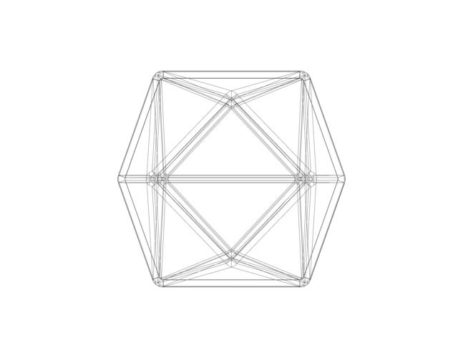

Key Points
# Source: AI Source: Provided by: [Data Path: Persons Table -> ID Column: 1, Name_En Column: Motasem Essam] -> From: [ChatGPT] on [7/25/2026]
- The Tetrakis Hexahedron is a Catalan solid.
- It is constructed from a cube with six attached square pyramids.
- It has 24 congruent isosceles triangular faces.
- It has 36 edges and 14 vertices.
- Its edges consist of 24 shorter edges and 12 longer edges.
- Its vertices have two configurations: degree 4 and degree 6.
- It is the dual of the Truncated Octahedron.
- It has full octahedral symmetry $O_{h}$.
- It is convex and face-transitive.

Conclusion
# Source: AI Source: Provided by: [Data Path: Persons Table -> ID Column: 1, Name_En Column: Motasem Essam] -> From: [ChatGPT] on [7/25/2026]
The Tetrakis Hexahedron is an important member of the Catalan solids family. Its distinctive structure is created by attaching six square pyramids to a cube. Its 24 congruent triangular faces, two types of vertices, and dual relationship with the Truncated Octahedron make it an excellent example of polyhedral construction and geometric duality.

